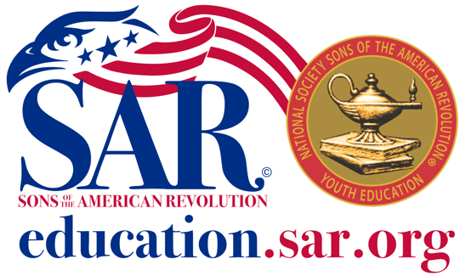
SAR YOUTH VIDEO CONTEST

- INTRODUCTION

The National Society Sons of the American Revolution (NSSAR) is developing a SAR Youth Video Contest to promote education, research, and creative expression regarding the American Revolution for high school-age participants. This contest is open to all high school students (9th through 12th grades) attending public, parochial, home, or private high schools. This contest is also open to participants of equivalent age in organizations such as Boy Scouts, Girl Scouts, Children of the American Revolution, and other youth organizations recognized by the NSSAR Council of Youth Programs.

- RULES AND GUIDELINES

  - The subject of the entry should focus on an event, personality, document, or topic pertaining to the American Revolution. Emphasis on the 250th anniversary of the Revolution is recommended.
  - Entries must contain ORIGINAL content. Content must be based on scholarly research of the presented topic. Content may not violate copyright laws.
  - Video presentation must be three to five minutes in content length. Credit or references will not count toward the video content length.
  - Entries may be submitted in the following formats:
MP4
MOV
WMV
AVI
  - The style, approach, and perspective are not limited. The entry may be in the form of a documentary, dramatization, interview, advertisement, etc. Creativity is encouraged.
  - While some creative license is permitted, historical accuracy is essential. For example, a conversation that never occurred may be acceptable but must adhere to currently known historical facts.
  - A minimum of three references is required. All references should be cited in the end credits and on the application form.
  - All entries are judged blind to the identity and home location of the contestant.
  - Entries may be submitted by a single contestant or by a group. Any group project will be considered a single entry, and only one award and cash prize (if any) will be presented per entry.
  - Contestants must submit two versions of their entry. One version should contain full titles, end credits, and the name of the creator(s)/contestant(s). The second version may also contain full titles and end credits, but all references to the creator(s)/contestant(s) must be absent. End title credit for the contestant(s) for additional contributions (e.g., as an actor) may be included, provided it does not obviously indicate the identity of the individual(s) as a contestant(s).
  - Contestants understand and agree their entry video may be shown at SAR meetings or other events. It may also be posted on various websites and available for public viewing. Therefore, contestants must read, understand, and sign the Youth Programs Release Form. In addition, ALL INDIVIDUALS appearing in the video entry must also sign and submit the Youth Programs Release Form. A parent/guardian MUST SIGN if the individual is a minor.
  - The Sons of the American Revolution is a non-profit 501(c)3 organization and is prohibited from endorsing or promoting any political party, candidate, or position. Therefore, all contest entries must likewise refrain from including any political content.

- JUDGING CRITERIA
  - Historical Content
  - General Presentation
  - Impression and Creativity
  - Audio and Visual Presentation
  - Production
  - Contest Rules Compliance

- POSTER CONTEST PRIZES FOR SAR VIDEO CONTEST

  - First Place: $xx, plus SAR Certificate
  - Second Place: $xx, plus SAR Certificate
  - Third Place: $xx, plus SAR Certificate

- WHERE AND WHEN TO SUBMIT

  - Submissions are made at the chapter level. xxSSAR has xx chapters that represent the xx counties in the state. To contact the chapter responsible for your county, click on (insert link).
  - The contest calendar will generally correspond to the school calendar.
  - New projects and submissions may begin in late summer and will be accepted after 1 September. The deadline for submission of entries at the Chapter level shall be 1 February.
  - The deadline for submission at the State level shall be 1 March.
  - Final State level judging and selection of winners must be completed by 15 March.
  - The deadline for submission at the National level shall be 1 May.
  - National judging shall be completed, and the winners selected by 1 June.

- QUESTIONS? Contact your local chapter or the xxSSAR Chair, (name), (email), and (phone number).

For information about other Youth Programs and educational resources on the American Revolution, visit

education.sar.org

