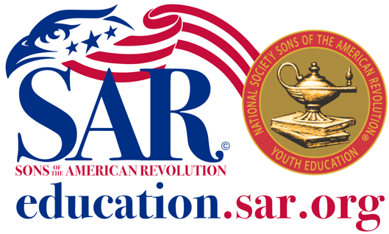

George S. & Stella M. Knight

Essay High School Contest

The National Society of the Sons of the American Revolution (SAR) invite all high school students (9th through 12th grades) interested in the American Revolution to participate in the George S. & Stella M. Knight Essay Contest. The contest is open to all US citizens and legal resident students attending home schools, public, parochial, or private high schools in that same grade range. The National Association of Secondary School Principals has placed this program on the 2017-18 NASSP List of Approved Contests, Programs, and Activities for Students. To participate, students must submit an original 800 to 1,200-word essay based on an event, person, philosophy, or ideal associated with the American Revolution, Declaration of Independence, or the framing of the United States Constitution. Each student’s essay will be judged based on its historical accuracy, clarity, organization, grammar, spelling, and documentation.
The contest is conducted in three phases: the local chapter, state-level society, and national phases. The contest must be entered through a SAR chapter near the student’s residence. In some cases, the contest may be entered at the state level. The essay judged to excel will be awarded an honorarium for the scholarship.
- Chapter and State Award: Varies according to chapter and state. To find your local Chapter contact the primary contact in your state at this link sar.org/find-your-contact
- Nation Award: Primary honoree: $5,000; a medal and recognition certificate; up to $500 toward travel expenses and one-night hotel stay for the winner and a chaperone at the annual SAR Congress. Secondary Honoree: $2,500 and a recognition certificate. Tertiary $1,000 and a recognition certificate.
Only one entry per student is permitted per contest year. A complete set of rules and the application for both the applicant and the sponsoring SAR members can be found below. Please note that the Chapter and State application deadline dates may vary, so interested applicants should contact their local SAR Chapter for further details. To find your local Chapter contact the primary contact in your state at this link sar.org/find-your-contact

The National Society, Sons of the American Revolution, and the General Society, Sons of the Revolution are patriotic, historical, and educational nonprofit 501C3 corporations that seek to maintain and extend the institutions of American freedom, patriotism, and respect for the symbols of our nation, including, but not limited to promoting our founding ideals, pride in being American citizens, and the unifying force of E Pluribus Unum.

